301 607 8163 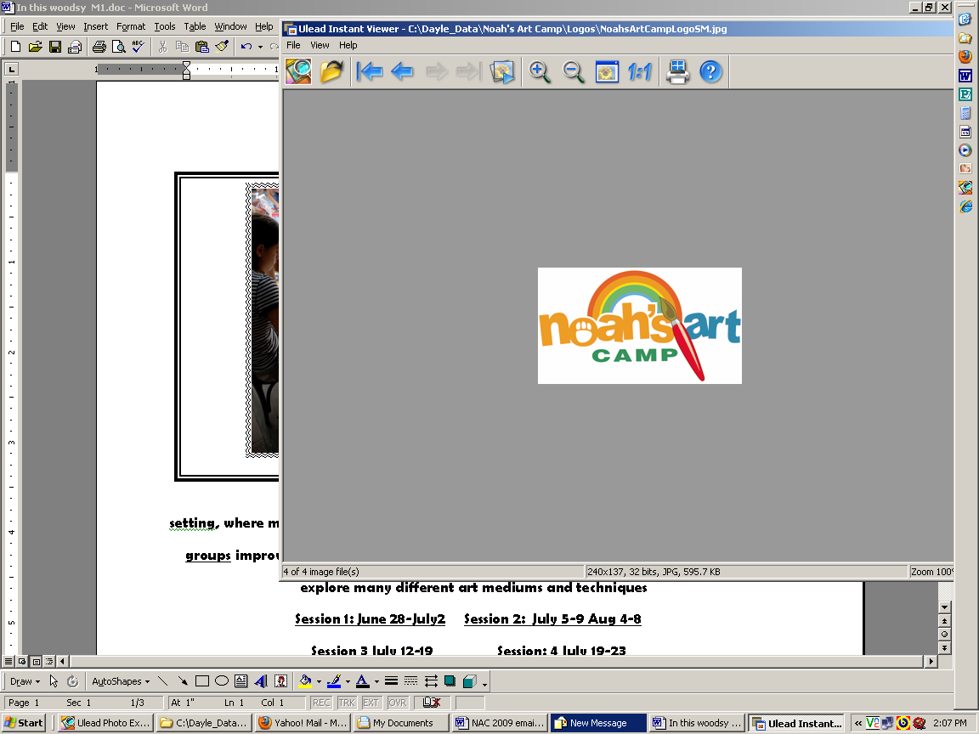
Hello Campers,

Each morning we will come together to create art and enjoy the nature around us. Prek – K Session will be Tues. thru Fri. from 9-11:45. As before there will be tame bunnies, guinea pigs, ducks and chickens to pose for you. Henrietta the cockatiel, will talk to you and show off her feathers as you sketch. Lady, our little soft doggie, and Bo Jangles and Gracie, our cute cats, will be around for you to cuddle or draw if you wish. We are still allowing a Bunny or Guinea Pig to go home for an overnight visit with your parent’s permission. I currently have baby bunnies. Please make requests by letter or note with day requested before and after camp so I can organize carriers, food, water & etc. and provide a smooth pick up for going home. I hope to make sure everyone desiring an animal overnight gets a chance to enjoy this exciting opportunity. This has proven such a positive experience and I want all campers to have a chance:>) ( I love you guys)
The “creek walks” are still part of our camp experience and we have extra nets for the fun of minnow catching while we wade. Careful supervision is always provided.
Each week includes two and three dimensional projects you will be taking home. Different projects are created each session if you’d like to attend more than one week of camp.
Campers will be making great art using clay, paper mache, oil pastel, paint, pencil, or collage and cartooning. In case of rain or heat we use indoor locations also.
“ I know campers will be better able to draw, paint and work with clay by the end of camp. They will return to their school year more comfortable with a variety of techniques and supplies for creating their art.”
Looking forward to seeing you,

Miss Dayle - dayleduffy@yahoo.com 301 607 8163, ( MCPS Art Teacher/Artist 28 years)
------------------------------------------------------------------------------------

Please send this portion and payment to

Noah’s Art Camp / P.O. Box 762 / Mt. Airy, Md. 21771

Session/s preferred_______ Name/s___________________________Age/s_____

Phone Email

